**Mathematical Report**

**Arham ijaz**

[Year]

**Mathematical Report**

|  |  |  |  |  |
| --- | --- | --- | --- | --- |
| **(x1,y1)** | | **(x2,y2)** | | **Distance** |
| x1 | y1 | x2 | y2 |  |
| 1 | 2 | 5 | 10 | 8.94 |
| 2 | 4 | 3 | 6 | 2.24 |
| 3 | 6 | 4 | 8 | 2.24 |
| 4 | 8 | 1 | 2 | 6.71 |
| 5 | 10 | 2 | 4 | 6.71 |

**Mathematical Formulas**

1. **Distance:** It is distance covered between two points. Distance between two points P(x1, y1) and Q(x2, y2) is given by: d(P, Q) = p(x2 − x1)2 + (y2 − y1)2 {Distance formula}
2. **Midpoint:** It is middle point between two points. Midpoint between two points P(x1, y1) and Q(x2, y2) is given by: m(P, Q) = p(x1+x2)/2 + (y1 + y2)/2 {Midpoint formula}

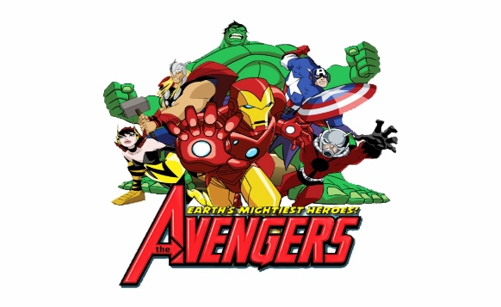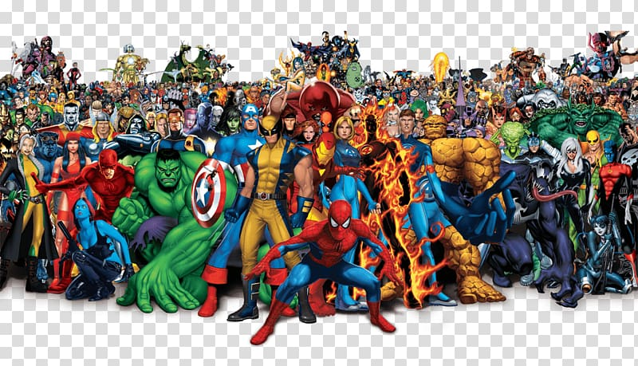Marvel consists of comic-based characters created by Stan Lee .Every character got a special power which differentiate it from others.

Marvel's The Avengers or simply The Avengers, is a 2012 American [superhero film](https://en.wikipedia.org/wiki/Superhero_film) based on the [Marvel Comics](https://en.wikipedia.org/wiki/Marvel_Comics) superhero team [of the same name](https://en.wikipedia.org/wiki/Avengers_(comics)).

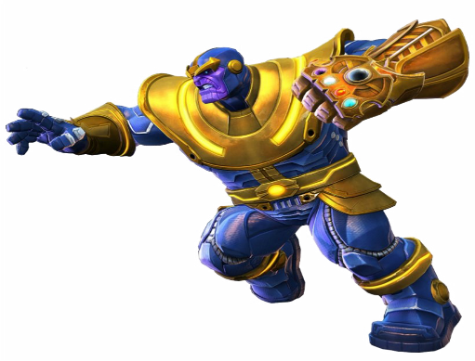

**T**

**hanos** is a fictional character appearing in [American comic books](https://en.wikipedia.org/wiki/American_comic_book) published by [Marvel Comics](https://en.wikipedia.org/wiki/Marvel_Comics). He was created by writer-artist [Jim Starlin](https://en.wikipedia.org/wiki/Jim_Starlin), and made his debut in [*Invincible Ironman Man*](https://en.wikipedia.org/wiki/Iron_Man_(comic_book))

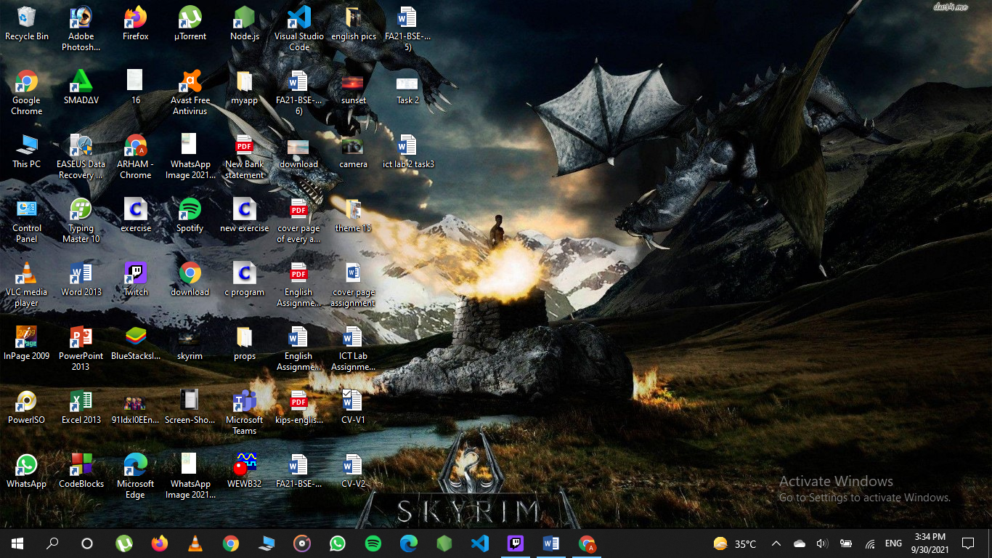

<https://sites.google.com/a/ciitlahore.edu.pk/introtocit/course-material>